Artworks Desc Khairul Izzati

1 Eurasian Hoopoe

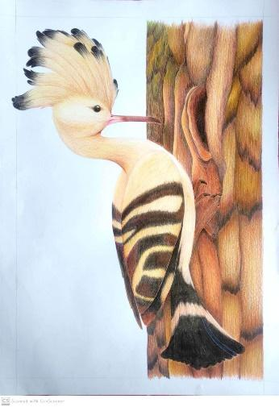

This drawing portrays an Eurasian Hoopoe resting on a side of a tree bark. The medium used are pencil and colour pencil on an A2 paper.

2 Spring Fox

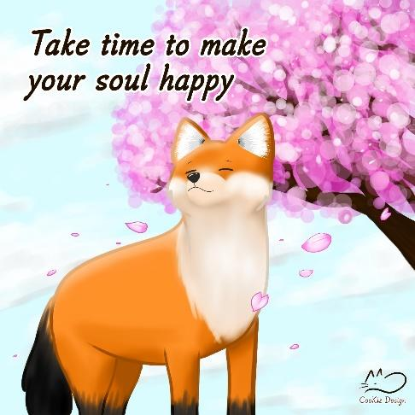

I love foxes and Japan so this drawing is the combination of both. It also reminds me to always give myself time to do the things that would make me happy no matter how busy I was.

3 Light vs Dark

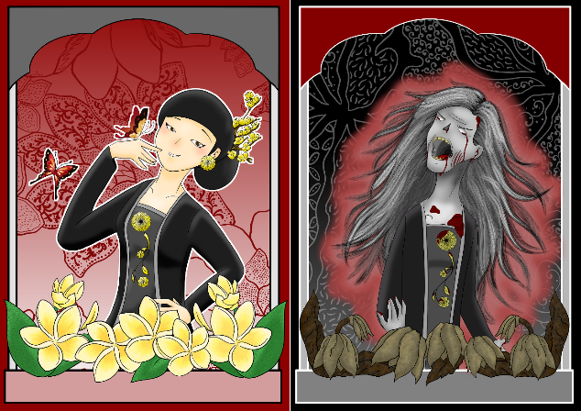

These two drawings portrays the light side and the dark side on the usage of enchanted needles also known as ‘susuk’. The beauty of a person will be enhanced when wearing ‘susuk’ but when the person had broke the taboo, the person will become horrifying and ugly.

4 Tuned in Imagination

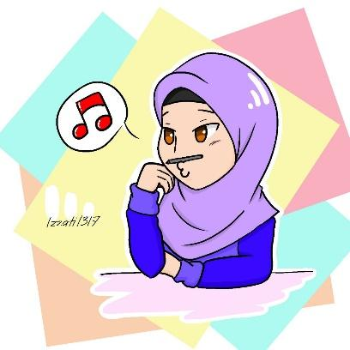

This simple illustration and style is what matches me perfectly. It also shows how I would usually be like when running through my train of thoughts.

**- 1 favorite quote**

Breathe deeply, Live fully

**- short bio (50-150 words max)**

I’m a 25-year-old artist who loves cats, foxes, flowers and anything fluffy. My favourite style of drawing is simplicity and a bit Islamic but I still love to venture more styles and using various mediums. A fun fact, I would be in the zone when listening to either a horror story podcast or a killer documentary podcast. Very contradicting from what I hear which is horror and educational with what I draw which is cutesy and vibrant. Hahaha..

**- socmed handle or email**

Facebook: CooKiz Design

Instagram: @cookiz_design

Email: khairul.izzati1317@gmail.com